**Demonstrate how to run a collection remotely with URL**

**Step-1:**

First I open postman and then open my collection

Step-2:

Then Click on 3 dots and click on Share

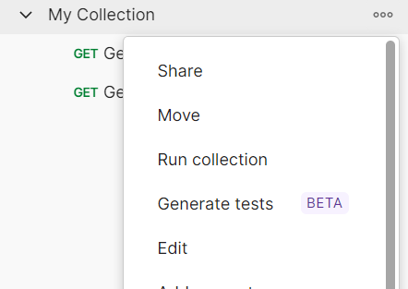

**Step-3:**

Then I click on via api and then click on generate new key

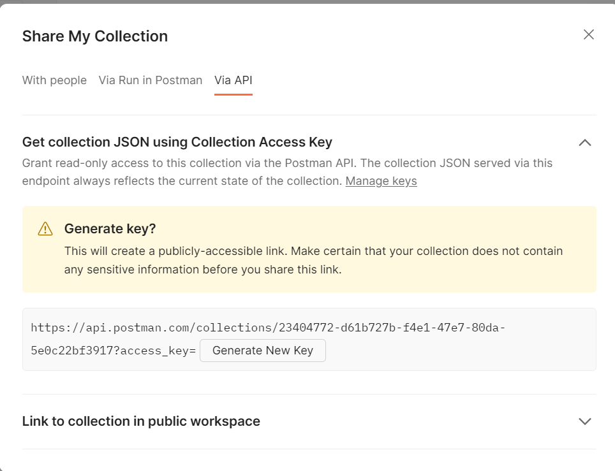

**Step-4:**

Then I copied the url

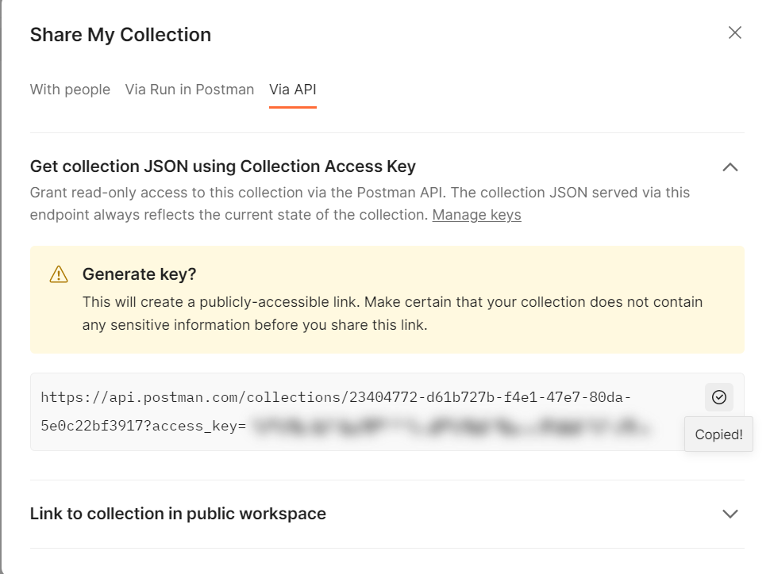

**Step-5:**  Then I open command prompt and run it

